1. y(a, b, c, d) = [a(b + cd)]’

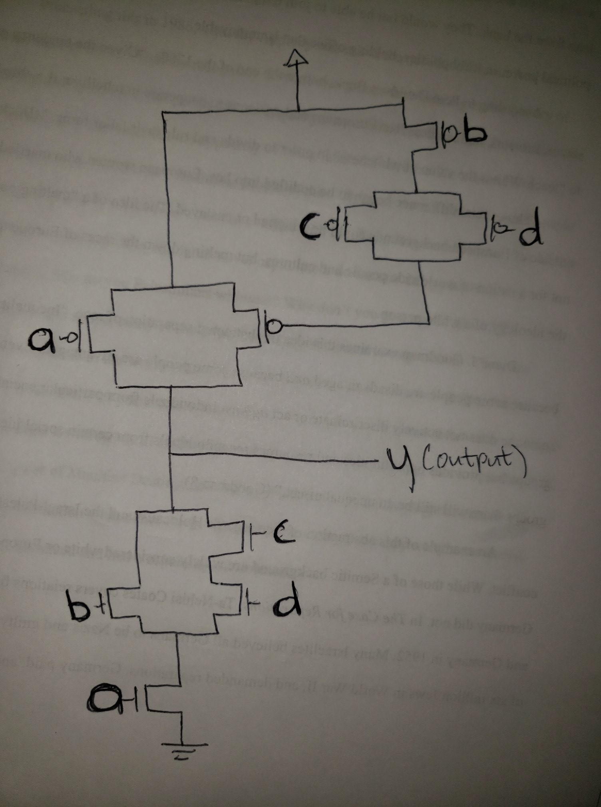

2)

|  |  |  |  |  |  |  |  |  |  |
| --- | --- | --- | --- | --- | --- | --- | --- | --- | --- |
| a5 | a4 | a3 | a2 | a1 | a0 |  | **y2** | **y1** | **y0** |
| 0 | 0 | 0 | 0 | 0 | 0 |  | **0** | **0** | **0** |
| 0 | 0 | 0 | 0 | 0 | 1 |  | **0** | **0** | **1** |
| 0 | 0 | 0 | 0 | 1 | 0 |  | **0** | **0** | **1** |
| 0 | 0 | 0 | 0 | 1 | 1 |  | **0** | **1** | **0** |
| 0 | 0 | 0 | 1 | 0 | 0 |  | **0** | **0** | **1** |
| 0 | 0 | 0 | 1 | 0 | 1 |  | **0** | **1** | **0** |
| 0 | 0 | 0 | 1 | 1 | 0 |  | **0** | **1** | **0** |
| 0 | 0 | 0 | 1 | 1 | 1 |  | **0** | **1** | **1** |
| 0 | 0 | 1 | 0 | 0 | 0 |  | **0** | **0** | **1** |
| 0 | 0 | 1 | 0 | 0 | 1 |  | **0** | **1** | **0** |
| 0 | 0 | 1 | 0 | 1 | 0 |  | **0** | **1** | **0** |
| 0 | 0 | 1 | 0 | 1 | 1 |  | **0** | **1** | **1** |
| 0 | 0 | 1 | 1 | 0 | 0 |  | **0** | **1** | **0** |
| 0 | 0 | 1 | 1 | 0 | 1 |  | **0** | **1** | **1** |
| 0 | 0 | 1 | 1 | 1 | 0 |  | **0** | **1** | **1** |
| 0 | 0 | 1 | 1 | 1 | 1 |  | **1** | **0** | **0** |
| 0 | 1 | 0 | 0 | 0 | 0 |  | **0** | **0** | **1** |
| 0 | 1 | 0 | 0 | 0 | 1 |  | **0** | **1** | **0** |
| 0 | 1 | 0 | 0 | 1 | 0 |  | **0** | **1** | **0** |
| 0 | 1 | 0 | 0 | 1 | 1 |  | **0** | **1** | **1** |
| 0 | 1 | 0 | 1 | 0 | 0 |  | **0** | **1** | **0** |
| 0 | 1 | 0 | 1 | 0 | 1 |  | **0** | **1** | **1** |
| 0 | 1 | 0 | 1 | 1 | 0 |  | **0** | **1** | **1** |
| 0 | 1 | 0 | 1 | 1 | 1 |  | **1** | **0** | **0** |
| 0 | 1 | 1 | 0 | 0 | 0 |  | **0** | **1** | **0** |
| 0 | 1 | 1 | 0 | 0 | 1 |  | **0** | **1** | **1** |
| 0 | 1 | 1 | 0 | 1 | 0 |  | **0** | **1** | **1** |
| 0 | 1 | 1 | 0 | 1 | 1 |  | **1** | **0** | **0** |
| 0 | 1 | 1 | 1 | 0 | 0 |  | **0** | **1** | **1** |
| 0 | 1 | 1 | 1 | 0 | 1 |  | **1** | **0** | **0** |
| 0 | 1 | 1 | 1 | 1 | 0 |  | **1** | **0** | **0** |
| 0 | 1 | 1 | 1 | 1 | 1 |  | **1** | **0** | **1** |
| 1 | 0 | 0 | 0 | 0 | 0 |  | **0** | **0** | **1** |
| 1 | 0 | 0 | 0 | 0 | 1 |  | **0** | **1** | **0** |
| 1 | 0 | 0 | 0 | 1 | 0 |  | **0** | **1** | **0** |
| 1 | 0 | 0 | 0 | 1 | 1 |  | **0** | **1** | **1** |
| 1 | 0 | 0 | 1 | 0 | 0 |  | **0** | **1** | **0** |
| 1 | 0 | 0 | 1 | 0 | 1 |  | **0** | **1** | **1** |
| 1 | 0 | 0 | 1 | 1 | 0 |  | **0** | **1** | **1** |
| 1 | 0 | 0 | 1 | 1 | 1 |  | **1** | **0** | **0** |
| 1 | 0 | 1 | 0 | 0 | 0 |  | **0** | **1** | **0** |
| 1 | 0 | 1 | 0 | 0 | 1 |  | **0** | **1** | **1** |
| 1 | 0 | 1 | 0 | 1 | 0 |  | **0** | **1** | **1** |
| 1 | 0 | 1 | 0 | 1 | 1 |  | **1** | **0** | **0** |
| 1 | 0 | 1 | 1 | 0 | 0 |  | **0** | **1** | **1** |
| 1 | 0 | 1 | 1 | 0 | 1 |  | **1** | **0** | **0** |
| 1 | 0 | 1 | 1 | 0 | 1 |  | **1** | **0** | **0** |
| 1 | 0 | 1 | 1 | 1 | 0 |  | **1** | **0** | **0** |
| 1 | 0 | 1 | 1 | 1 | 1 |  | **1** | **0** | **1** |
| 1 | 1 | 0 | 0 | 0 | 0 |  | **0** | **1** | **0** |
| 1 | 1 | 0 | 0 | 0 | 1 |  | **0** | **1** | **1** |
| 1 | 1 | 0 | 0 | 1 | 0 |  | **0** | **1** | **1** |
| 1 | 1 | 0 | 0 | 1 | 1 |  | **1** | **0** | **0** |
| 1 | 1 | 0 | 1 | 0 | 0 |  | **0** | **1** | **1** |
| 1 | 1 | 0 | 1 | 0 | 1 |  | **1** | **0** | **0** |
| 1 | 1 | 0 | 1 | 1 | 0 |  | **1** | **0** | **0** |
| 1 | 1 | 0 | 1 | 1 | 1 |  | **1** | **0** | **1** |
| 1 | 1 | 1 | 0 | 0 | 0 |  | **0** | **1** | **1** |
| 1 | 1 | 1 | 0 | 0 | 1 |  | **1** | **0** | **0** |
| 1 | 1 | 1 | 0 | 1 | 0 |  | **1** | **0** | **0** |
| 1 | 1 | 1 | 0 | 1 | 1 |  | **1** | **0** | **1** |
| 1 | 1 | 1 | 1 | 0 | 0 |  | **1** | **0** | **0** |
| 1 | 1 | 1 | 1 | 0 | 1 |  | **1** | **0** | **1** |
| 1 | 1 | 1 | 1 | 1 | 0 |  | **1** | **0** | **1** |
| 1 | 1 | 1 | 1 | 1 | 1 |  | **1** | **1** | **0** |

Y0 = a5’a4’a3a2’a1’a0’ + a5’a4’a3’a2’a1a0’ + a5’a4’a3’a2a1’a0’ + a5’a4’a3’a2a1a0 + a5’a4’a3a2’a1’a0’ + a5’a4’a3a2’a1a0 + a5a4’a3’a2’a1’a0’ + a5a4’a3’a2’a1a0 + a5a4’a3’a2a1’a0 + a5a4’a3’a2a1a0’ + a5a4’a3a2’a1’a0 + a5a4’a3a2’a1a0’ + a5a4’a3a2a1’a0’ + a5a4’a3a2a1a0 + a5’a4a3’a2’a1’a0’ + a5’a4a3’a2’a1a0 + a5’a4a3’a2a1’a0 + a5’a4a3’a2a1a0’ + a5’a4a3a2’a1’a0 + a5’a4a3a2’a1a0’ + a5’a4a3a2a1’a0’ + a5’a4a3a2a1a0 + a5a4a3’a2’a1’a0 + a5a4a3’a2’a1a0’ + a5a4a3’a2a1’a0’ + a5a4a3’a2a1a0 + a5a4a3a2’a1’a0’ + a5a4a3a2’a1a0 + a5a4a3a2a1’a0 + a5a4a3a2a1a0’

Y1 = a5’a4’a3’a1a0 + a5’a4’a3’a2a1 + a5’a4’a3a2’a0 + a5’a4’a3a2’a1 + a5’a4’a3a2a0’ + a5’a4’a2a1’a0 + a5a4’a3’a2a0’ + a5a4’a3a2’a1’ + a5a4’a2’a1a0’ + a5a4’a2’a1’a0 + a5a4’a3’a1’a0 + a5a4’a3’a2’a1 + a5’a4a3’a2a0’ + a5’a4a3a1’a0’ + a5’a4a2’a1a0’ + a5’a4a2’a1’a0 + a5’a4a3’a2’a0 + a5’a4a3’a1’a0 + a5a4a3’a2’a1’ + a5a4a3’a2’a0’ + a5a4a3’a1’a0’ + a5a4a2’a1’a0’ + a5a4a3a2a1a0

Y2 = a5’a4’a3a2a1a0 + a5a4’a2a1a0 + a5a4’a3a1a0 + a5a4’a3a2a0 + a5a4’a3a2a1 + a5’a4a2a1a0 + a5’a4a3a1a0 + a5’a4a3a2a0 + a5a4a3a2 + a5a4a1a0 + a5a4a2a0 + a5a4a3a0 + a5a4a2a1 + a5a4a3a1

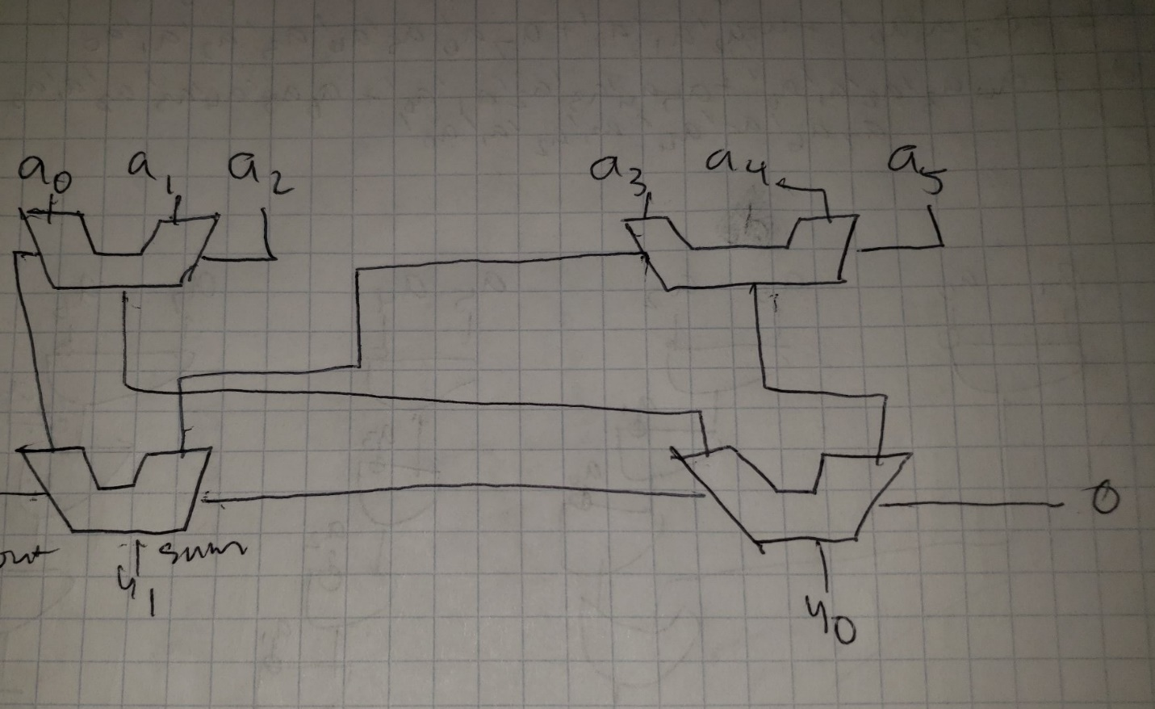

3)

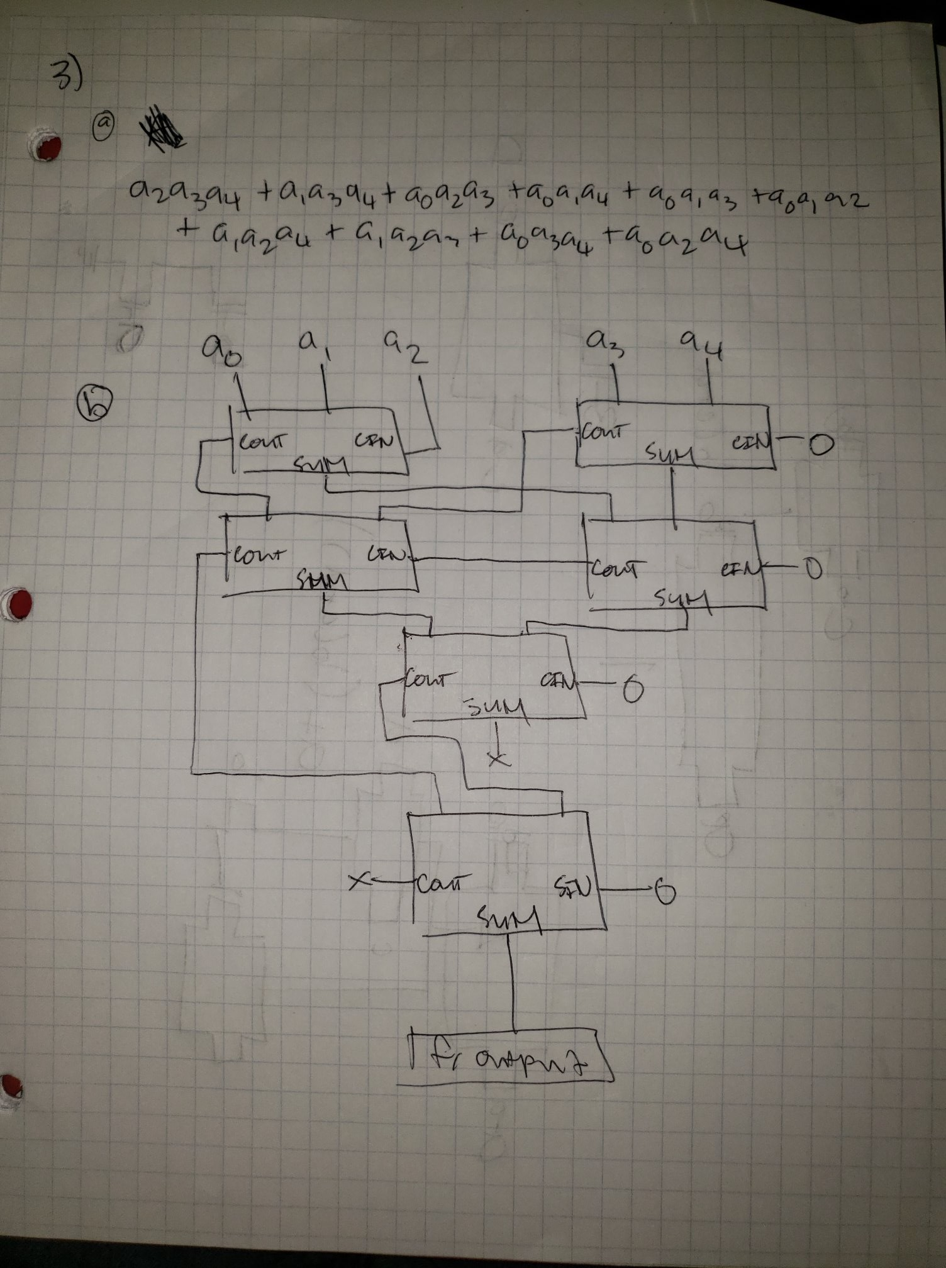

4) 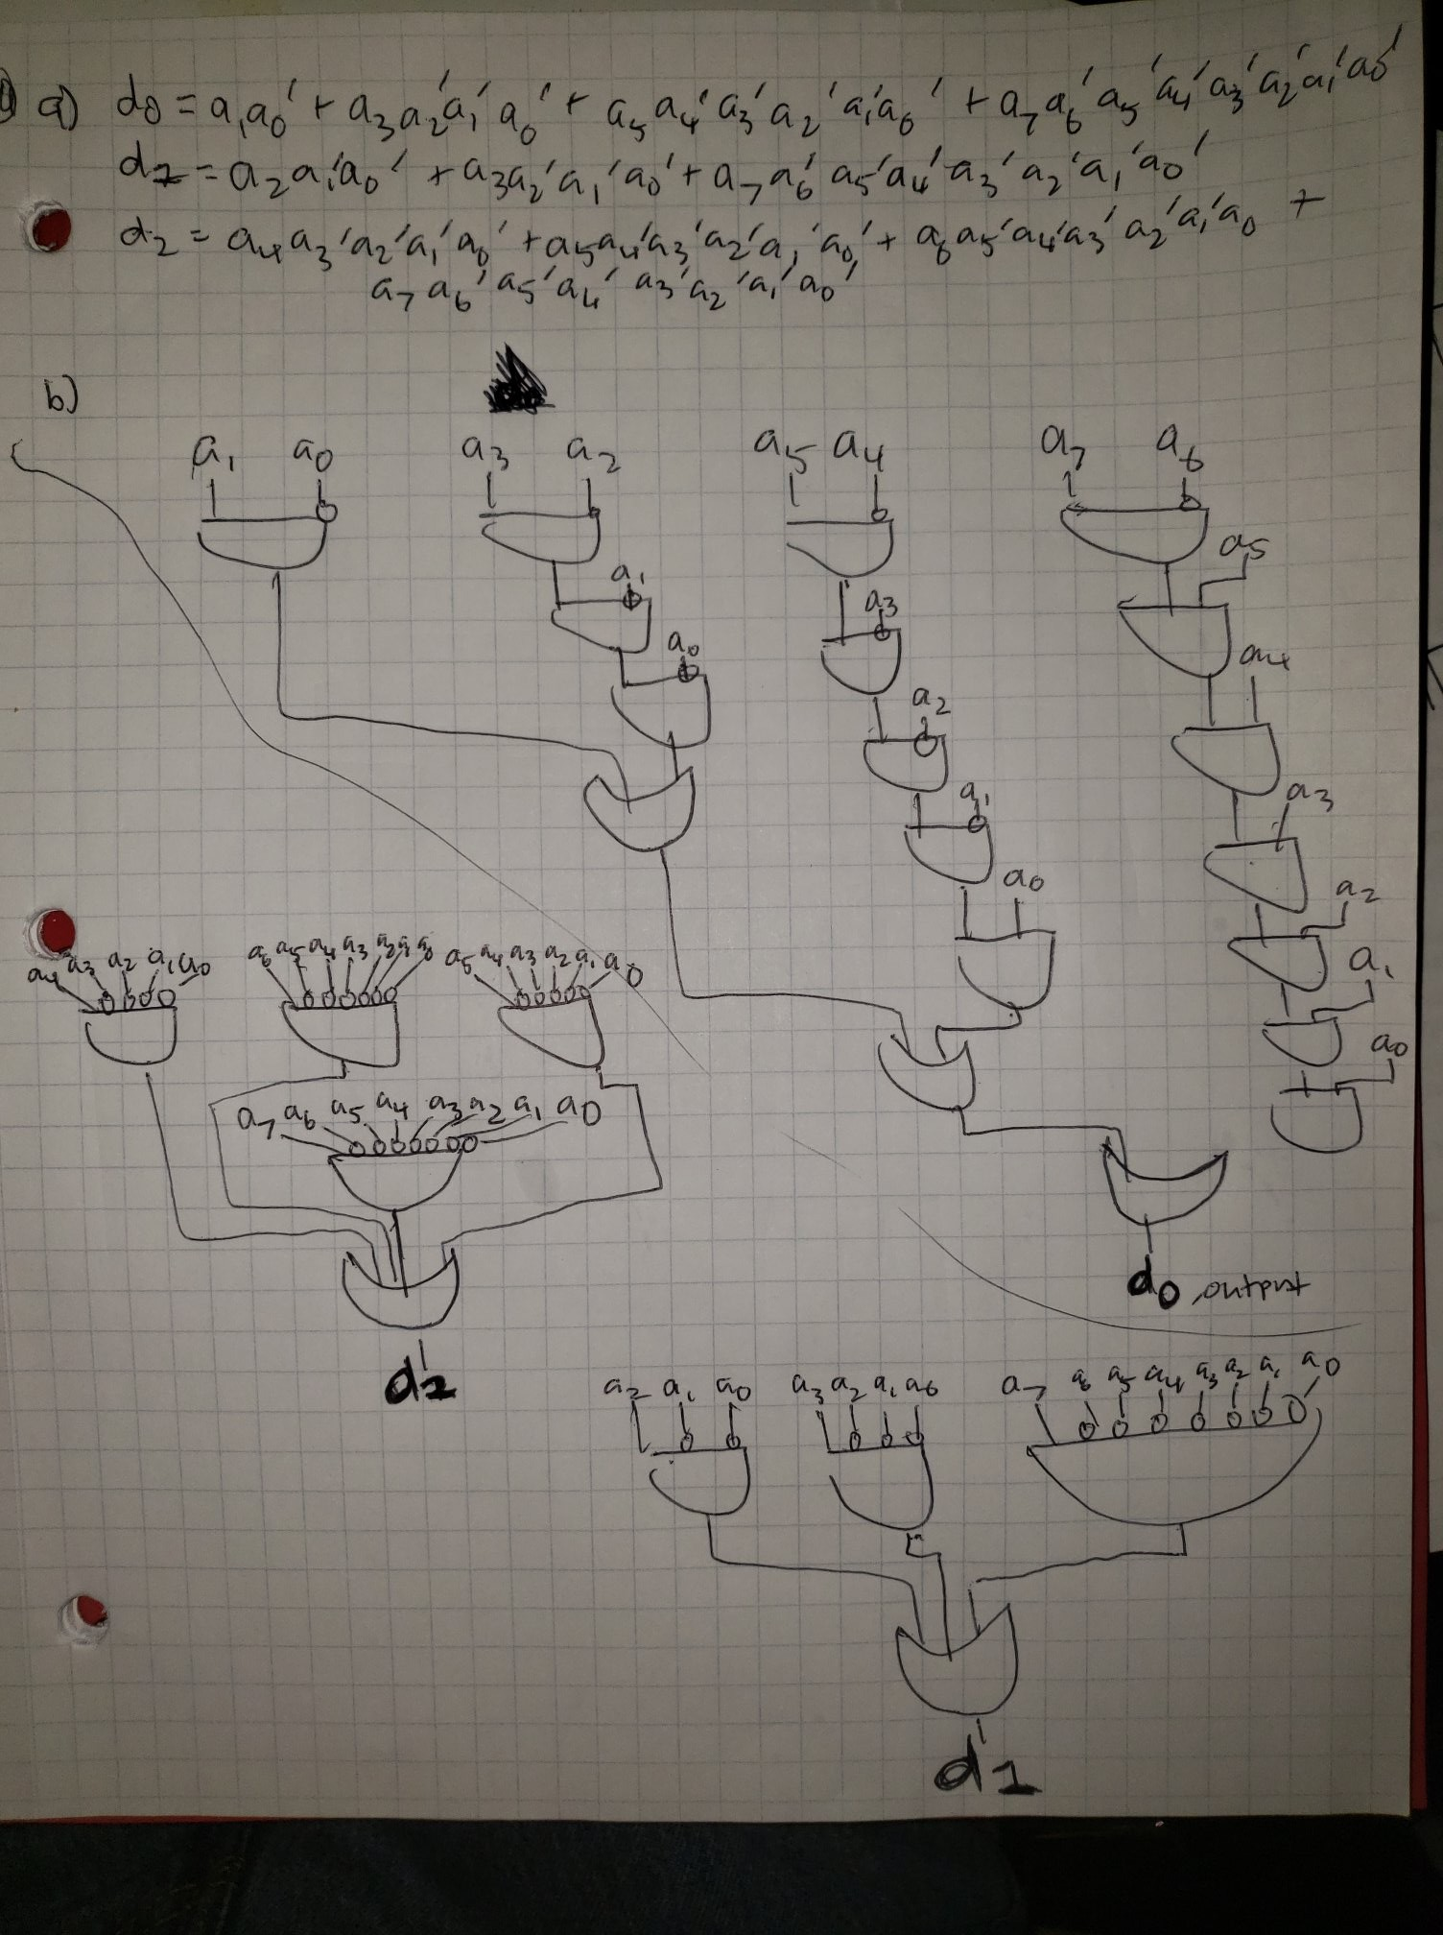

5) 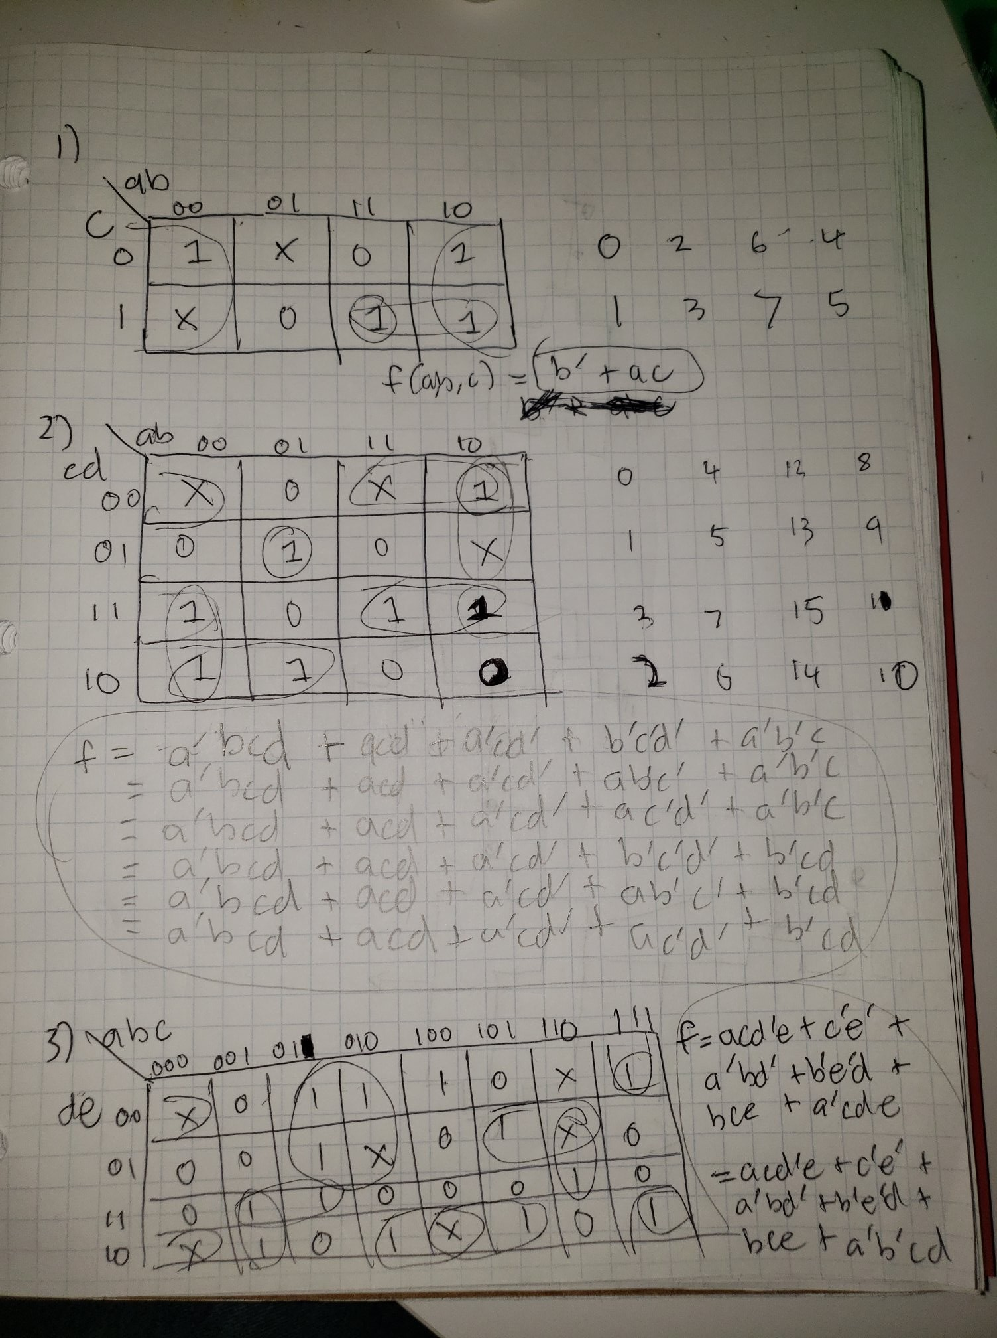

6) 